**I claim the set command.**

**According to https://www.gnu.org/software/bash/manual/html_node/The-Set-Builtin.html**

**,If no options or arguments are supplied, set displays the names and values of all shell variables and functions, sorted according to the current locale, in a format that may be reused as input for setting or resetting the currently-set variables. Read-only variables cannot be reset. In POSIX mode, only shell variables are listed. When options are supplied, they set or unset shell attributes.**

**When I was working on the first decision script, this command (set -x in particular) echoed the lines of the script while it ran. That made it a little easier to see errors and the lines of the script they referred to on the same read-out.**

Figure man for set

**This screenshot shows running the script with no arguments, with *set -x* in the script, showing the lines of the script as it runs.**

**This screenshot shows a script without arguments, and with no set in the script. It only displays the output of the script**

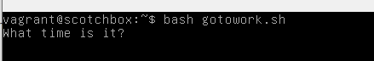

Figure info set